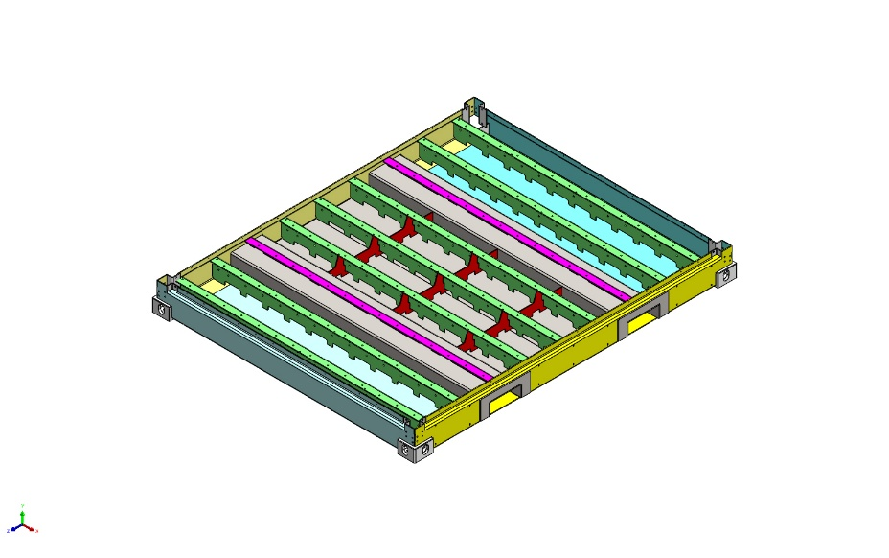 | Simulation of P000014110FLR  Date: Thursday, June 11, 2026  Designer: Solidworks  Study name: Static 2 zonder batterijmodule en dak  Analysis type: Static  Table of Contents  Description 1  Assumptions 2  Model Information 3  Study Properties 6  Units 6  Material Properties 7  Loads and Fixtures 9  Connector Definitions 10  Contact Information 10  Mesh information 11  Sensor Details 12  Resultant Forces 13  Beams 13  Study Results 14  Conclusion 16  Appendix 16

Description
No Data

Assumptions

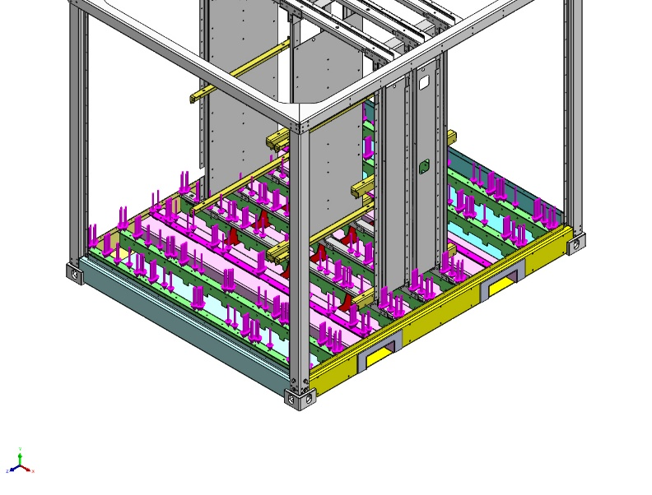  Original Model | 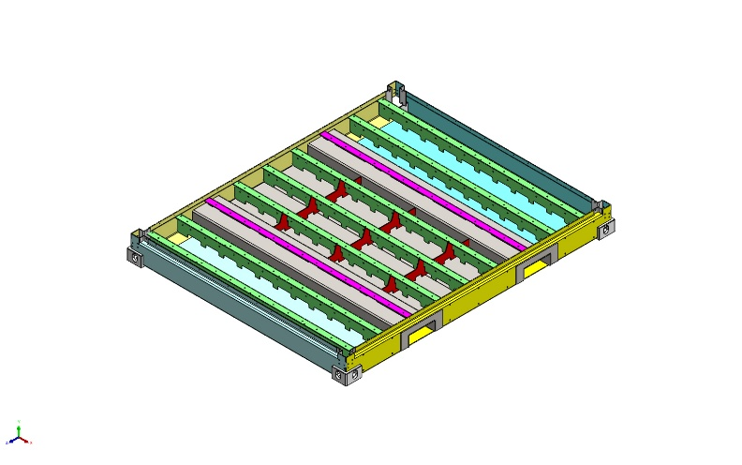  Model Analyzed

Model Information

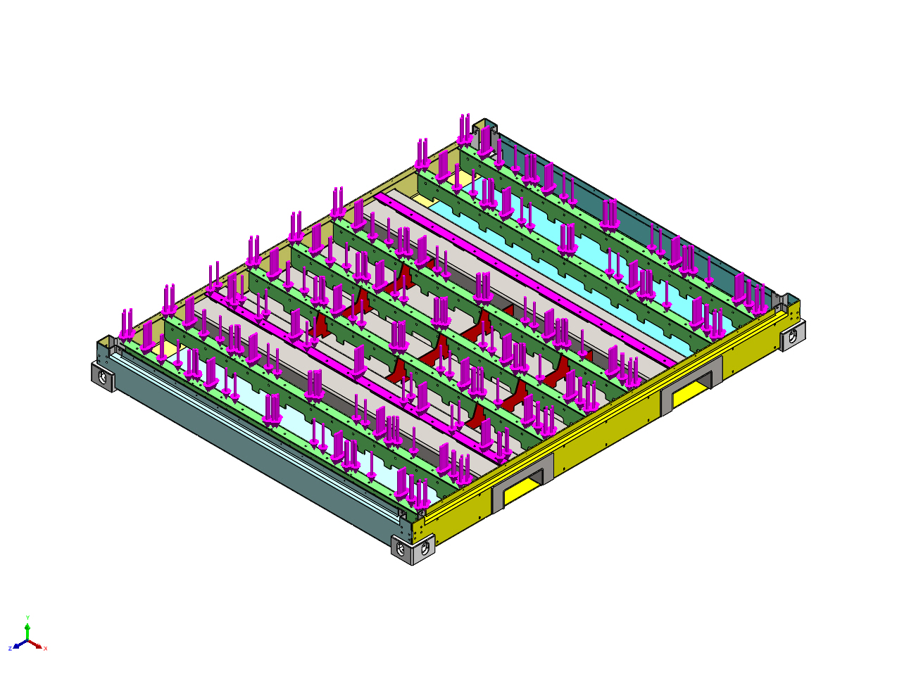
Model name: P000014110FLR
Current Configuration: Default
Solid Bodies
Document Name and Reference | Treated As | Volumetric Properties | Document Path/Date Modified
Fillet11  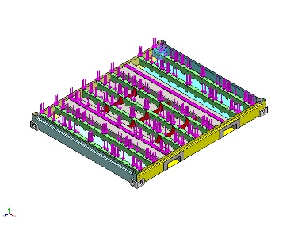 | Solid Body | Mass:12.3782 kg  Volume:0.00157523 m^3  Density:7,858 kg/m^3  Weight:121.306 N | G:\03_Projects_Business_Dev\00056 e-PU10 V1\04_Engineering\05) Mechanical stress analysis\Floor okt 2025\P000008405FLR.SLDPRT  Sep 9 07:22:34 2025
Fillet11  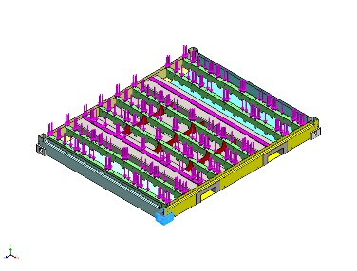 | Solid Body | Mass:12.3782 kg  Volume:0.00157523 m^3  Density:7,858 kg/m^3  Weight:121.306 N | G:\03_Projects_Business_Dev\00056 e-PU10 V1\04_Engineering\05) Mechanical stress analysis\Floor okt 2025\P000008405FLR.SLDPRT  Sep 9 07:22:34 2025
<P000003232>-<Fillet11> | Solid Body | Mass:12.3783 kg  Volume:0.00157524 m^3  Density:7,858.04 kg/m^3  Weight:121.307 N | G:\03_Projects_Business_Dev\00056 e-PU10 V1\04_Engineering\05) Mechanical stress analysis\Floor okt 2025\P000008411FLR.sldprt  Oct 13 12:59:26 2025
<P000003232>-<Fillet11> | Solid Body | Mass:12.3783 kg  Volume:0.00157524 m^3  Density:7,858.04 kg/m^3  Weight:121.307 N | G:\03_Projects_Business_Dev\00056 e-PU10 V1\04_Engineering\05) Mechanical stress analysis\Floor okt 2025\P000008411FLR.sldprt  Oct 13 12:59:26 2025
Boss-Extrude1  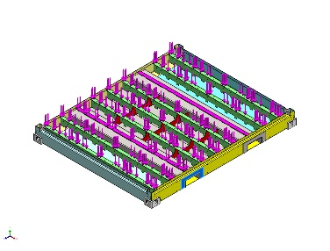 | Solid Body | Mass:3.60204 kg  Volume:0.0004618 m^3  Density:7,800 kg/m^3  Weight:35.3 N | C:\Users\pdmdesktop\AppData\Local\Temp\swx123644\VC~~\P000014110FLR\Part1^P000014110FLR.SLDPRT  Jun 11 12:31:23 2026
Boss-Extrude1  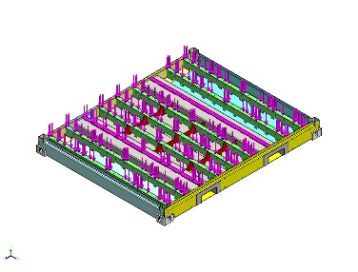 | Solid Body | Mass:3.60204 kg  Volume:0.0004618 m^3  Density:7,800 kg/m^3  Weight:35.3 N | C:\Users\pdmdesktop\AppData\Local\Temp\swx123644\VC~~\P000014110FLR\Part1^P000014110FLR.SLDPRT  Jun 11 12:31:23 2026
Boss-Extrude1  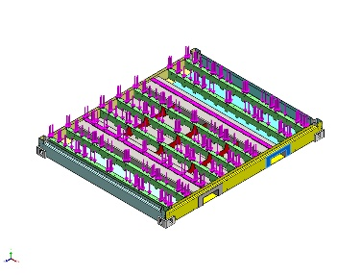 | Solid Body | Mass:3.60204 kg  Volume:0.0004618 m^3  Density:7,800 kg/m^3  Weight:35.3 N | C:\Users\pdmdesktop\AppData\Local\Temp\swx123644\VC~~\P000014110FLR\Part1^P000014110FLR.SLDPRT  Jun 11 12:31:23 2026
Boss-Extrude1  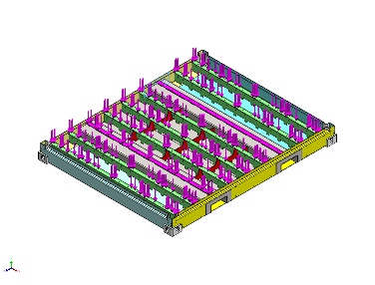 | Solid Body | Mass:3.60204 kg  Volume:0.0004618 m^3  Density:7,800 kg/m^3  Weight:35.3 N | C:\Users\pdmdesktop\AppData\Local\Temp\swx123644\VC~~\P000014110FLR\Part1^P000014110FLR.SLDPRT  Jun 11 12:31:23 2026

Study Properties
Study name | Static 2 zonder batterijmodule en dak
Analysis type | Static
Mesh type | Mixed Mesh
Thermal Effect: | On
Thermal option | Include temperature loads
Zero strain temperature | 298 Kelvin
Include fluid pressure effects from SOLIDWORKS Flow Simulation | Off
Solver type | Automatic
Inplane Effect: | Off
Soft Spring: | Off
Inertial Relief: | Off
Incompatible bonding options | Automatic
Large displacement | Off
Compute free body forces | On
Friction | Off
Use Adaptive Method: | Off
Result folder | SOLIDWORKS document (G:\03_Projects_Business_Dev\00056 e-PU10 V1\04_Engineering\05) Mechanical stress analysis\Floor okt 2025)

Units
Unit system: | SI (MKS)
Length/Displacement | mm
Temperature | Kelvin
Angular velocity | Rad/sec
Pressure/Stress | N/m^2

Material Properties
Model Reference | Properties | Components
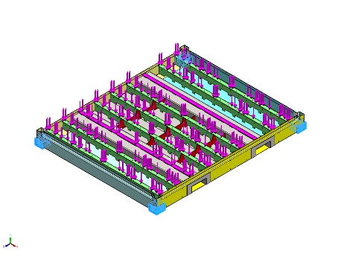 | Name: CARBON STEEL  Model type: Linear Elastic Isotropic  Default failure criterion: Unknown  Yield strength: 2.82685e+08 N/m^2  Tensile strength: 4.25e+08 N/m^2  Elastic modulus: 2.05e+11 N/m^2  Poisson's ratio: 0.29  Mass density: 7,858 kg/m^3  Shear modulus: 8e+10 N/m^2  Thermal expansion coefficient: 1.2e-05 /Kelvin | SolidBody 1(Fillet11)(P000008405FLR-2),  SolidBody 1(Fillet11)(P000008405FLR-3),  SolidBody 1(<P000003232>-<Fillet11>)(P000008411FLR-1),  SolidBody 1(<P000003232>-<Fillet11>)(P000008411FLR-2)
Curve Data:N/A
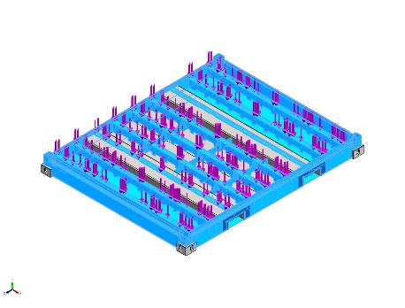 | Name: 1.0976 (S355MC)  Model type: Linear Elastic Isotropic  Default failure criterion: Unknown  Yield strength: 3.15e+08 N/m^2  Tensile strength: 4.9e+08 N/m^2  Elastic modulus: 2.1e+11 N/m^2  Poisson's ratio: 0.28  Mass density: 7,800 kg/m^3  Shear modulus: 7.9e+10 N/m^2  Thermal expansion coefficient: 1.1e-05 /Kelvin | SolidBody 1(<P000014130FLR>-<Fillet2>)(P000014129FLR-4),  SolidBody 1(Fillet2)(P000014130FLR-1),  SolidBody 1(Fillet1)(P000014131FLR-1),  SolidBody 1(Fillet1)(P000014131FLR-2),  SolidBody 1(Fillet1)(P000014131FLR-3),  SolidBody 1(Fillet1)(P000014131FLR-4),  SolidBody 1(Fillet1)(P000014131FLR-5),  SolidBody 1(Fillet1)(P000014131FLR-6),  SolidBody 1(Fillet1)(P000014131FLR-7),  SolidBody 1(<P000014138FLR>-<M6 Tapped Hole1>)(P000014137FLR-1),  SolidBody 1(M6 Tapped Hole1)(P000014138FLR-2),  SolidBody 1(Cut-Extrude8)(P000014145FLR-1),  SolidBody 1(Cut-Extrude8)(P000014145FLR-3),  SolidBody 1(Ø12.0 (12) Diameter Hole1)(P000014148FLR-1),  SolidBody 1(Ø12.0 (12) Diameter Hole1)(P000014148FLR-10),  SolidBody 1(Ø12.0 (12) Diameter Hole1)(P000014148FLR-11),  SolidBody 1(Ø12.0 (12) Diameter Hole1)(P000014148FLR-3),  SolidBody 1(Ø12.0 (12) Diameter Hole1)(P000014148FLR-4),  SolidBody 1(Ø12.0 (12) Diameter Hole1)(P000014148FLR-5),  SolidBody 1(Ø12.0 (12) Diameter Hole1)(P000014148FLR-6),  SolidBody 1(Ø12.0 (12) Diameter Hole1)(P000014148FLR-9),  SolidBody 1(Fillet1)(P000014149FLR-1),  SolidBody 1(Fillet1)(P000014149FLR-2),  SolidBody 1(Fillet1)(P000014149FLR-3),  SolidBody 1(Boss-Extrude1)(Part1^P000014110FLR-1),  SolidBody 1(Boss-Extrude1)(Part1^P000014110FLR-2),  SolidBody 1(Boss-Extrude1)(Part1^P000014110FLR-3),  SolidBody 1(Boss-Extrude1)(Part1^P000014110FLR-4)
Curve Data:N/A
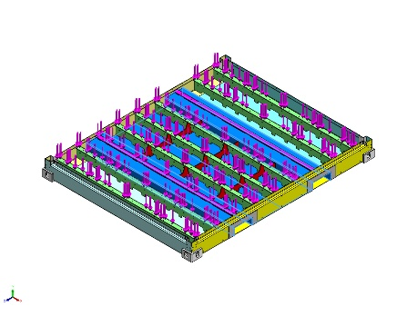 | Name: 1.0577 (S355J2)  Model type: Linear Elastic Isotropic  Default failure criterion: Max von Mises Stress  Yield strength: 3.15e+08 N/m^2  Tensile strength: 4.9e+08 N/m^2  Elastic modulus: 2.1e+11 N/m^2  Poisson's ratio: 0.28  Mass density: 7,800 kg/m^3  Shear modulus: 7.9e+10 N/m^2  Thermal expansion coefficient: 1.1e-05 /Kelvin | SolidBody 1(Boss-Extrude2)(P000014147FLR-1),  SolidBody 1(Boss-Extrude2)(P000014147FLR-2)
Curve Data:N/A

Loads and Fixtures
Fixture name | Fixture Image | Fixture Details
Reference Geometry-1 | 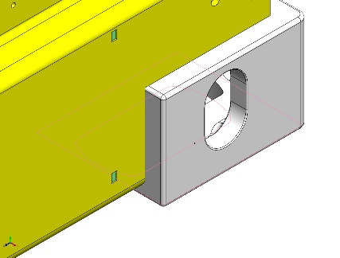 | Entities: 1 vertex(s)  Reference: Face< 1 >  Type: Use reference geometry  Translation: 0, 0, ---  Rotation: 0, 0, 0  Units: mm, rad
Resultant Forces
Components | X | Y | Z | Resultant
Reaction force(N) | 1.01328e-06 | 0 | -4.33624e-06 | 4.45305e-06
Reaction Moment(N.m) | 0 | 0 | 0 | 1e-33

Virtual wall-2714 | 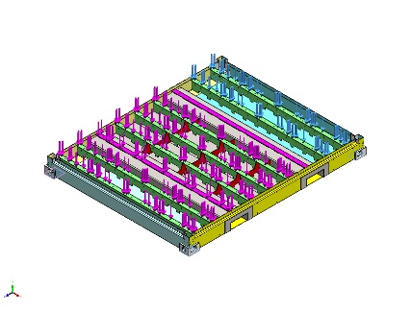 | Type: Virtual wall  Entities: 4 face(s), 1 plane(s)  Wall Type: Rigid

Load name | Load Image | Load Details
Force-4 | 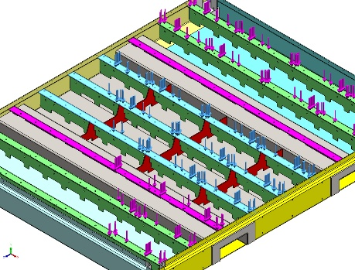 | Entities: 3 face(s)  Type: Apply normal force  Value: 113,000 N
Force-5 | 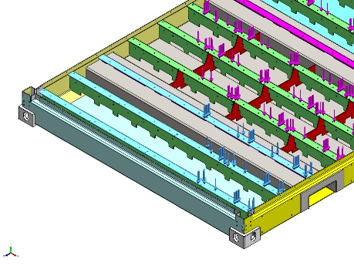 | Entities: 3 face(s)  Type: Apply normal force  Value: 39,101 N
Force-6 | 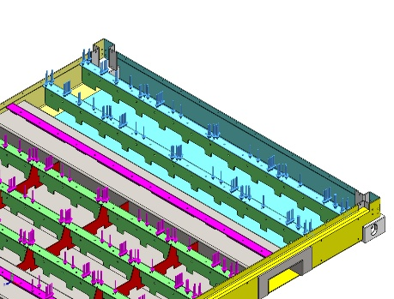 | Entities: 2 face(s)  Type: Apply normal force  Value: 900 N

Connector Definitions
No Data

Contact Information

Contact | Contact Image | Contact Properties
Global Contact | 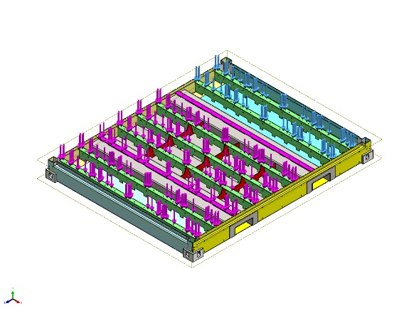 | Type: Bonded  Components: 1 component(s)  Options: Incompatible mesh

Mesh information
Mesh type | Mixed Mesh
Mesher Used: | Curvature-based mesh
Jacobian points for High quality mesh | 16 Points
Jacobian check for shell | On
Maximum element size | 82.6068 mm
Minimum element size | 27.5353 mm
Mesh Quality | High
Remesh failed parts with incompatible mesh | On

Mesh information - Details
Total Nodes | 185541
Total Elements | 93659
Time to complete mesh(hh;mm;ss): | 00:01:48
Computer name: | VES11D-007DT9S
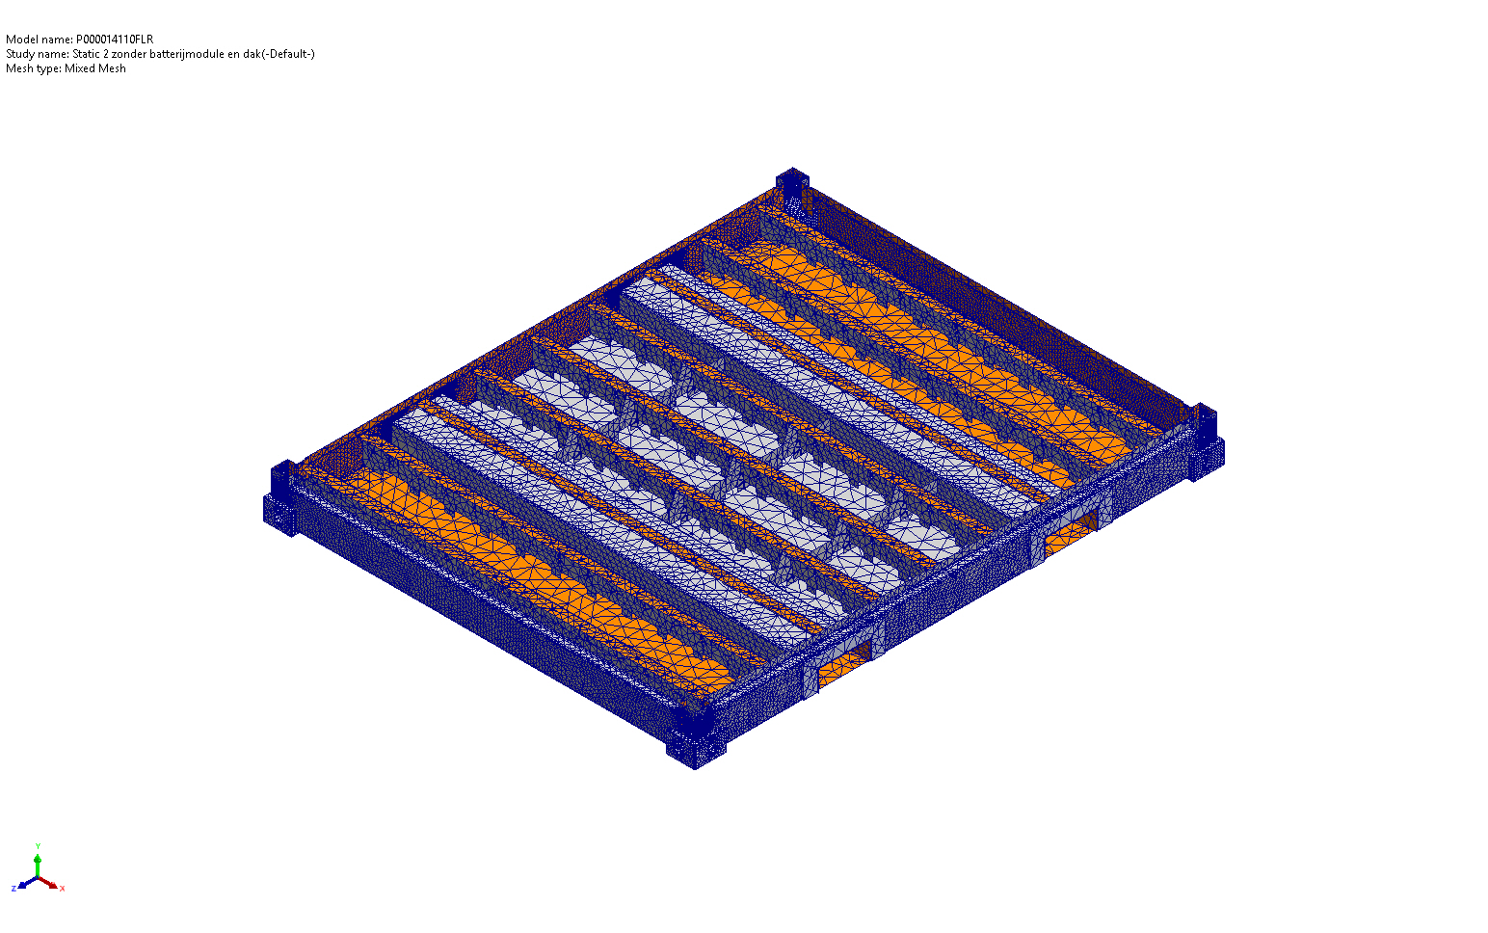

Mesh Control Information:
Mesh Control Name | Mesh Control Image | Mesh Control Details
Control-1 | 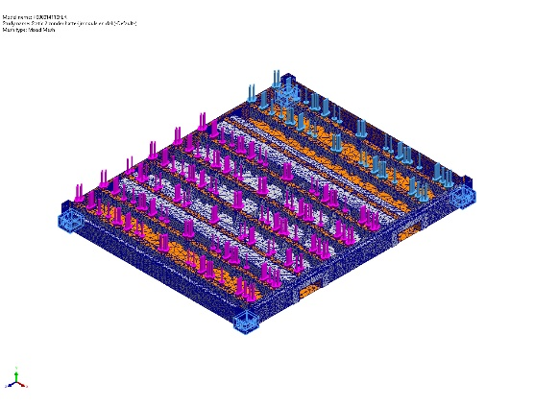 | Entities: 4 Solid Body (s)  Units: mm  Size: 15  Ratio: 15
Control-4 | 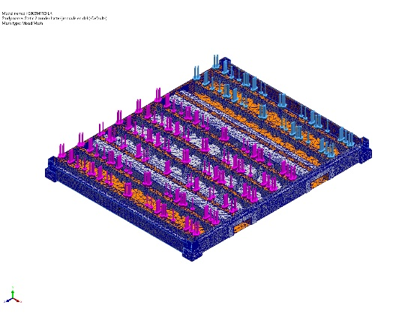 | Entities: 2 face(s)  Units: mm  Size: 20  Ratio: 20
Control-5 | 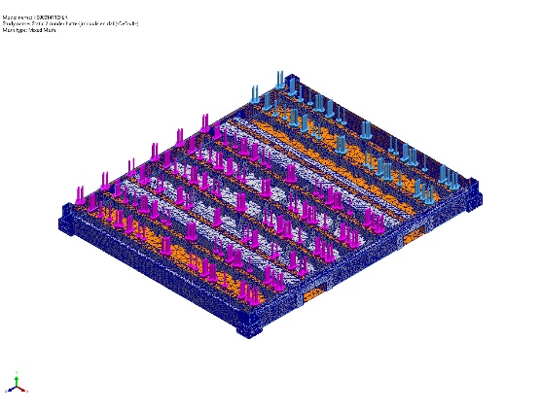 | Entities: 2 face(s)  Units: mm  Size: 19.4126  Ratio: 19.4126
Control-7 | 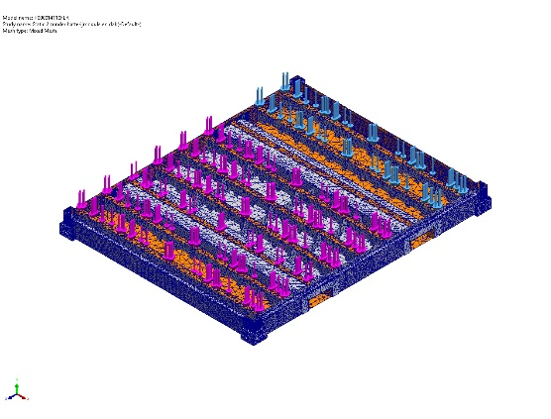 | Entities: 8 face(s)  Units: mm  Size: 2  Ratio: 2

Sensor Details
No Data

Resultant Forces

Reaction forces
Selection set | Units | Sum X | Sum Y | Sum Z | Resultant
Entire Model | N | 1.01328e-06 | 0 | -4.33624e-06 | 4.45305e-06

Reaction Moments
Selection set | Units | Sum X | Sum Y | Sum Z | Resultant
Entire Model | N.m | 0 | 0 | 0 | 1e-33

Free body forces
Selection set | Units | Sum X | Sum Y | Sum Z | Resultant
Entire Model | N | -0.0572248 | 0.0141314 | 0.249929 | 0.256786

Free body moments
Selection set | Units | Sum X | Sum Y | Sum Z | Resultant
Entire Model | N.m | 58.0001 | 3.22483 | 17.5126 | 60.6721

Beams
No Data

Study Results

Name | Type | Min | Max
Stress1 | VON: von Mises Stress | 1.830e+04N/m^2  Node: 121303 | 1.057e+09N/m^2  Node: 24429
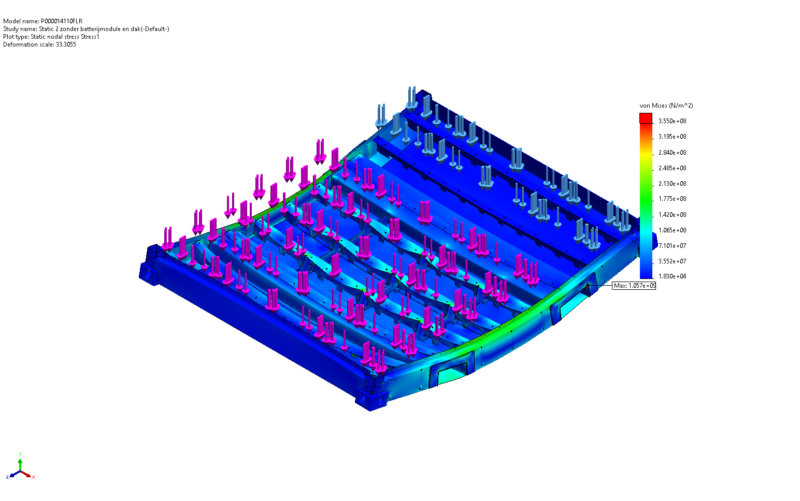
P000014110FLR-Static 2 zonder batterijmodule en dak-Stress-Stress1

Name | Type | Min | Max
Displacement1 | URES: Resultant Displacement | 2.162e-03mm  Node: 168922 | 9.005e+00mm  Node: 59026
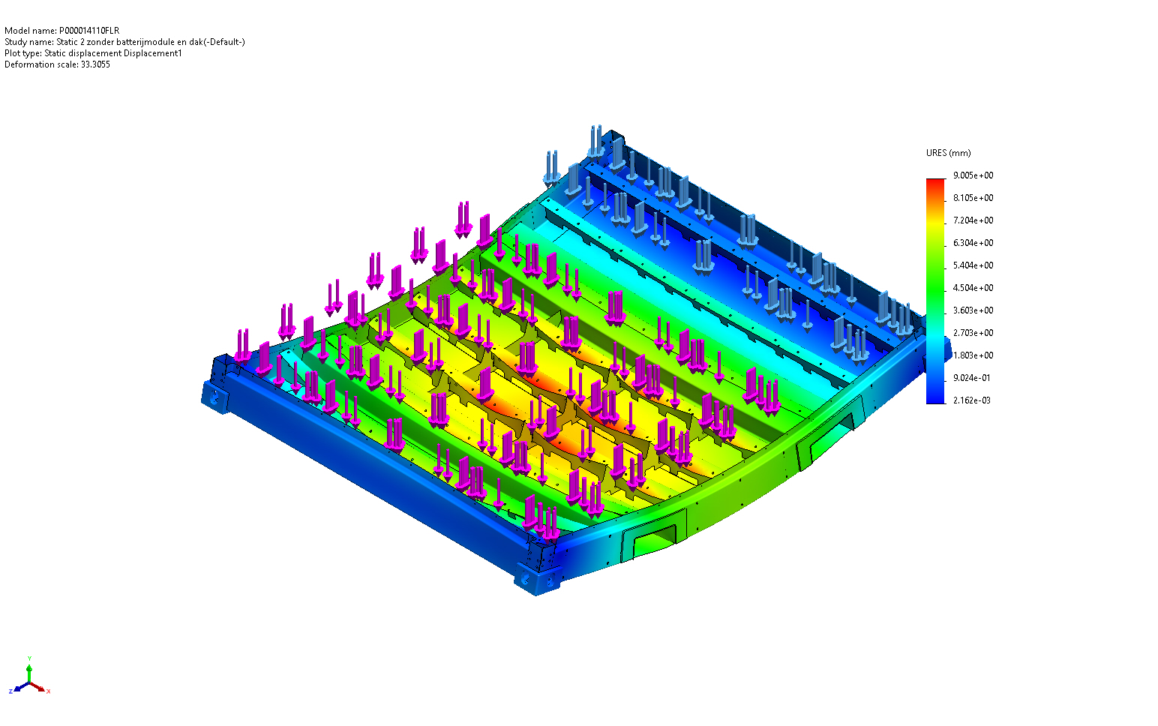
P000014110FLR-Static 2 zonder batterijmodule en dak-Displacement-Displacement1

Name | Type | Min | Max
Strain1 | ESTRN: Equivalent Strain | 9.460e-08  Element: 57139 | 1.343e-03  Element: 11900
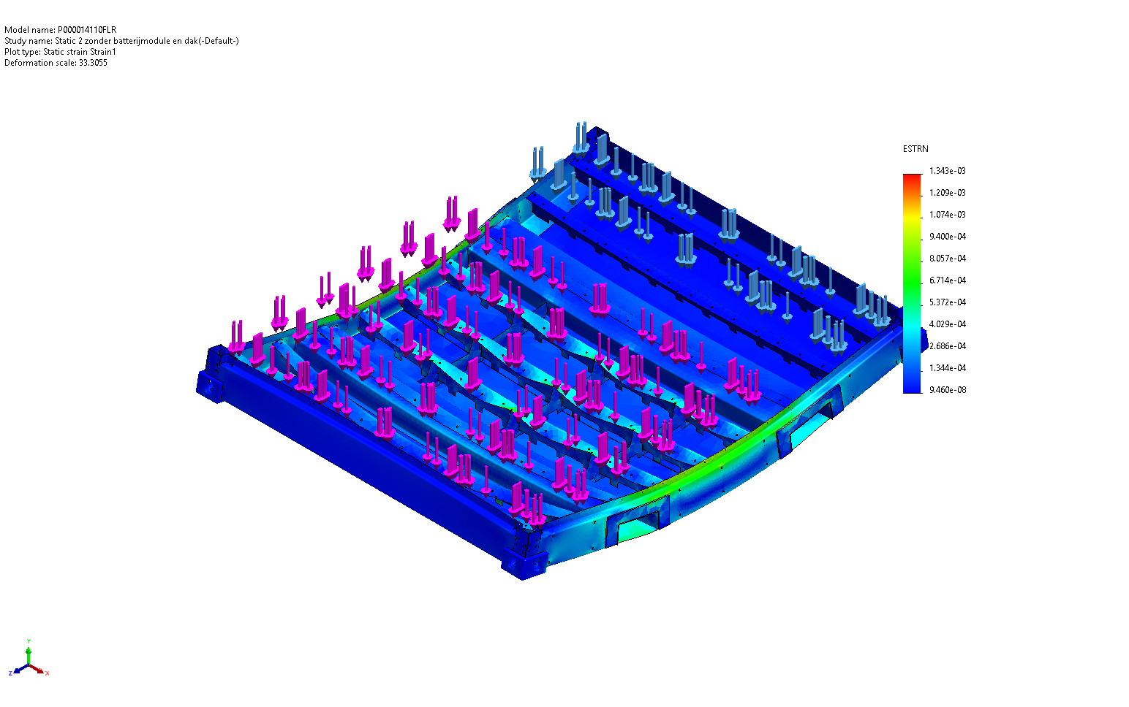
P000014110FLR-Static 2 zonder batterijmodule en dak-Strain-Strain1

Conclusion

Appendix

